**Frontend Development with React.js**

**Project Documentation format**

1. **Introduction**
   * **Project Title**: [fitflex Personal fitness companion]
   * **Team Members**:

Sanjay(Project Manager,Frontend Developer)

Siva A(backend developer)

Anandhan K(UI Desinger)

Baranivel k(Project Video Creater)

1. **Project Overview**
   * **Purpose**:
   * To promote a healthy lifestyle among users.
   * To help track fitness activities and diet easily.
   * To provide personalized workout and nutrition guidance.

* + **Features**:
  + User login and profile management.
  + Workout plans for different levels.
  + Diet and calorie tracking.
  + Community support and motivation.

1. **Architecture**
   * **Component Structure**:
   * Header / Navigation Bar – for easy app navigation.
   * Dashboard Component – shows fitness stats & progress.
   * Workout Component – workout plans & tutorials.
   * Diet Component – meal plans & calorie tracking.
   * **State Management**:
   * Manages user data (login, profile, fitness goals).
   * Tracks real-time changes (steps, calories, progress).
   * Uses centralized store (e.g., Redux / Context API if React).
   * Ensures data consistency across all components.
   * **Routing**:
   * Home Route → Dashboard.
   * /workout → Workout plans & tutorials.
   * /diet → Diet & nutrition details.
   * /progress → Reports & graphs.
   * /profile → User settings & account info.
   * /community → Social interaction & challenges.
2. **Setup Instructions**
   * **Prerequisites**:

* + Software Requirements:
  + Node.js (for frontend & backend setup)
  + npm or yarn (package manager)
  + Database (MySQL / MongoDB)
  + Code Editor (VS Code recommended)
  + Hardware Requirements:
  + Minimum 4GB RAM
  + 10GB free storage
  + Internet connection
  + **Installation**:
  + 1. Clone the Project
  + git clone <project-repo-link>
  + cd fitflex
  + 2. Install Dependencies
  + npm install
  + 3. Configure Database
  + Create a database in MySQL/MongoDB.
  + Update database credentials in config.js or .env file.
  + 4. Run Backend Server
  + npm run server
  + 5. Run Frontend Application
  + npm start
  + 6. Access Application
  + Open browser and go to:
  + <http://localhost:3000/>.

1. **Folder Structure**
   * **Client**: Client (Frontend)
   * /src
   * /components → Reusable UI parts (Navbar, Dashboard, WorkoutCard, etc.)
   * /pages → Screens like Home, Workout, Diet, Progress, Profile
   * /assets → Images, icons, styles
   * /routes → Routing setup (React Router).
   * **Utilities**: /utils
   * api.js → API call functions (fetching workout & diet data)
   * auth.js → Authentication helpers (login, logout, token handling)
   * validators.js → Input validation (email, password, etc.)
   * constants.js → Common constants (URLs, config).
2. **Running the Application**
   * 1. Go to Client Folder
   * cd fitflex/client
   * 2. Install Dependencies
   * npm install
   * 3. Start Frontend App
   * npm start
   * 4. Open in Browser
   * Visit 👉 <http://localhost:3000>.
     + **Frontend**: npm start in the client directory.
3. **Component Documentation**
   * **Key Components**:
   * Dashboard → Displays user progress, stats, and goals.
   * Workout → Shows workout plans and tutorials.
   * Diet → Provides meal plans and calorie tracking.
   * Profile → Manages user details and settings.
   * Community → Connects users through challenges & motivation..
   * **Reusable Components**:
   * Navbar / Header → Used for navigation across pages.
   * Footer → Common information and links.
   * Card Component → For workouts, diet plans, or progress display.
   * Button Component → Used across all forms and actions.
   * Form Input Component → For login, signup, and data entry.
4. **State Management**
   * **Global State**: Stores data shared across the app.
   * Example: User login details, authentication token, fitness goals, progress stats.
   * Managed using Context API / Redux for consistency.
   * **Local State**: Stores data used only inside a single component.
   * Example: Form inputs, modal open/close, step counter on a page.
   * Managed using useState hook in React..
5. **User Interface**
   * Login / Signup Page → Secure user authentication.
   * Dashboard → Displays fitness stats, goals, and progress.
   * Workout Page → Lists workout plans with tutorials.
   * Diet Page → Shows meal plans and calorie tracker.
   * Progress Page → Graphs and reports of user performance.
   * Profile Page → User details and settings.
   * Community Page → Social interaction, challenges, and leaderboards.
   * Navigation Bar → Easy access to all sections.
6. **Styling**

* **CSS Frameworks/Libraries**:
* Bootstrap / Tailwind CSS → For responsive design.
* Material UI → For modern and ready-to-use components..
* **Theming**:
* Light & Dark Mode for better user experience.
* Consistent Color Palette (fitness-oriented: green, blue, black).
* Reusable Styles for buttons, cards, and forms.
* Responsive Design to support mobile, tablet, and desktop..

1. **Testing**

* **Testing Strategy**: Unit Testing → Test individual components (e.g., Login form, Workout card).
* Integration Testing → Check if components work together (e.g., Dashboard fetching data).
* End-to-End Testing → Simulate user flow (login → workout → progress tracking).
* Manual Testing → UI/UX testing on different devices.
* **Code Coverage**: Ensure maximum test cases for critical features (Login, Workout, Diet, Progress).
* Use tools like Jest / Mocha for measuring coverage.
* Target: 70–80% code coverage for reliability..

1. **Screenshots or Demo**

* 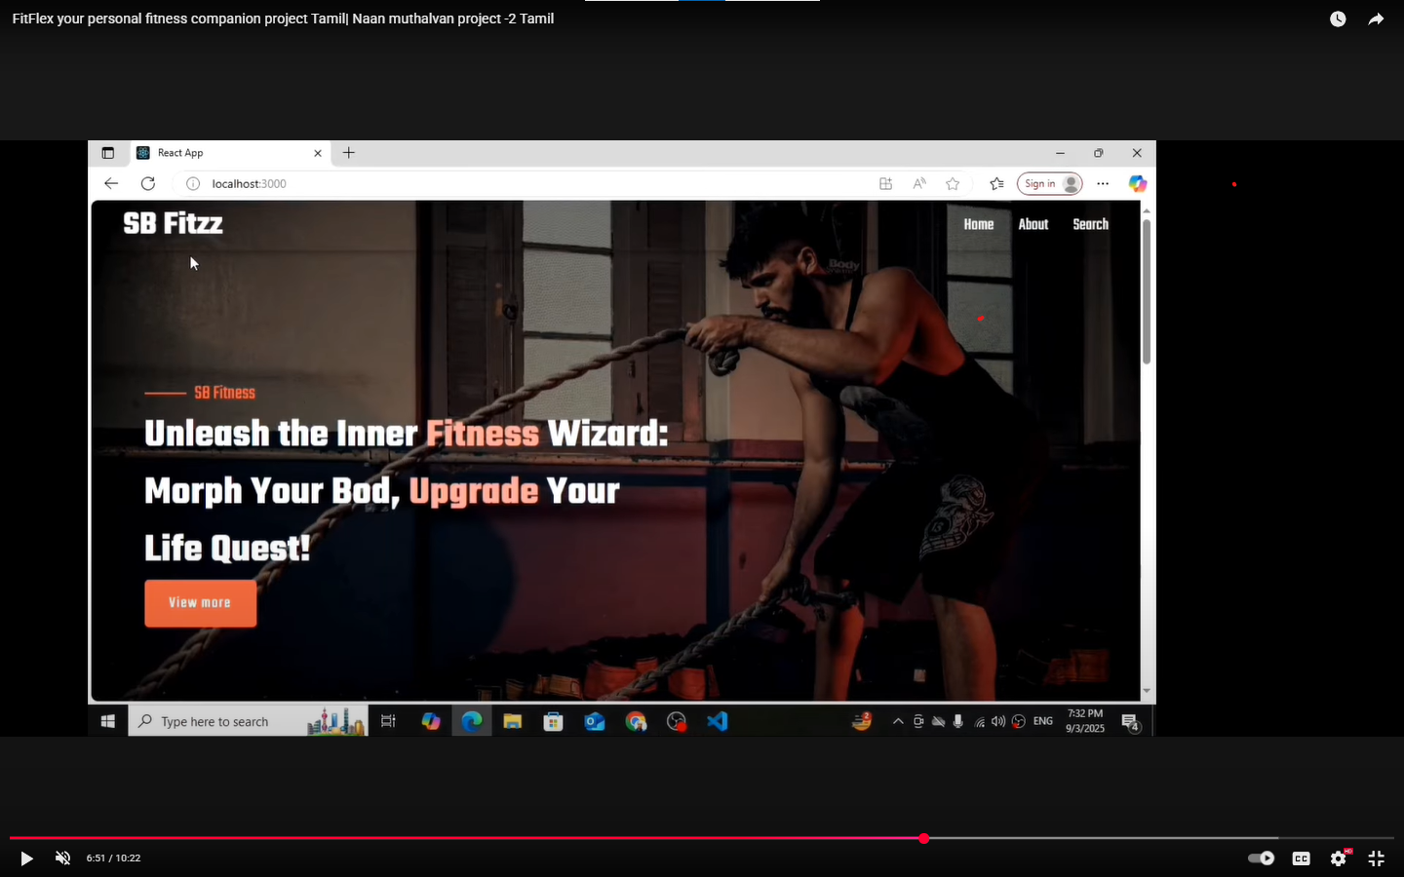.

1. **Known Issues**

* Limited offline support (needs internet for most features).
* No full wearable device integration (basic tracking only).
* AI-based suggestions are basic, not fully personalized.
* Community features are simple (no real-time chat).
* Works best on modern browsers; limited support on old devices..

1. **Future Enhancements**

* AI-Powered Personal Coach → Smarter workout & diet recommendations.
* Wearable Device Integration → Sync with smartwatches & fitness bands.
* Offline Mode → Basic tracking without internet.
* Advanced Community Features → Real-time chat, group challenges.
* Gamification → Rewards, badges, and points for motivation.
* Multi-language Support → Accessibility for more users.
* Cloud Sync → Access data across multiple devices.

**THANK YOU**